Mobile Canteen Request (UPDATED)
For Non-Military Events

Info about Requesting USO Northwest’s Mobile Canteen
- USO Northwest Mobile Canteen is a 32 ft long and 15 ft wide RV. Please ensure that there is suitable parking with adequate turnaround space at your event for a vehicle of this size.
- Sponsor of event is responsible for the cost of food as well as the Temporary Food Establishment Permit (TFEPs).
- The Mobile Canteen is required to have a Temporary Food Establishment Permit so requests must be made AT LEAST ONE MONTH in advance. Procedures on how to obtain a TFEP will be forwarded upon request.
- Our busiest time of year is May through November. We recommend sending your request as early as possible, especially during this time frame.

Requesting Organization Information

Organization/Unit Name: Click here to enter text.
POC Name and Title: Click here to enter text.
POC CELL Phone: Click here to enter text.
POC Email: Click here to enter text.

Event Information
Event Title: Click here to enter text.
Brief description of event: Click here to enter text.
Date: Click here to enter a date.
Event Time Start: Click here to enter text. End: Click here to enter text.
If food service is requested, what time should food service begin: Click here to enter text.

Event Location: Click here to enter text.
*NEW! (PLEASE PROVIDE A LAT/LONG coordinates for event location here)
Lat/Long:

Total Number of Attendees: Click here to enter text.
# of Active Duty: Click here to enter text.
# of National Guard/Reserve Adults: Click here to enter text.
# of Civilian Adults: Click here to enter text.
# of Children (under 13): Click here to enter text.

Military Branch Supported by Event (check all that apply):
☐Air Force ☐Army ☐Coast Guard ☐Marine ☐Navy ☐National Guard ☐Reserves

Mobile Canteen Services Requested (check all that apply):
☐USO Information
☐Food Services
☐ Breakfast (coffee/hot chocolate/water and donuts) – $3 per person served
☐ Lunch/Dinner (hotdogs~all beef, drinks, and *chips) – $5 per person served
☐ Snacks (chips, candy, misc.) based on donated inventory – $2 per person served
☐ Drinks (bottled water/ice tea/misc) likelihood 70%/20%/10% – $1 per person served
*(could be chips/dried fruit/nuts/misc) based on donated inventory

Please note any high ranking personnel/dignitaries who will be in attendance: Click here to enter text.

Comments/Special Requests:
Click here to enter text.

Please complete this form and return to the USO NW Mobile Canteen Manager
Once submitted to the Mobile Manager at the above email address, please text the Mobile Manager to advise of submittal.
Thomas Lancaster
253-336-6412

The completion of this form does not guarantee Mobile Canteen services. The Mobile Canteen Manager will contact you with confirmation and/or follow up questions as quickly as possible.
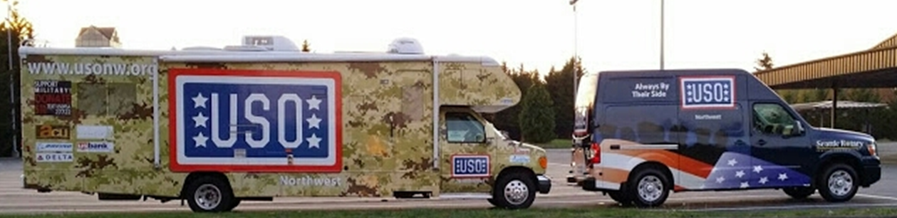
USO Northwest Mobile USO Canteens

